**Golden Arduino**

**Objective:**

A board like Arduino Uno was designed with a focus on modular separation and enhanced debugging capabilities, featuring additional test points to simplify the debugging process during development and testing phases. Industry best practices were implemented, including the integration of a separate ground plane, essential decoupling, and low-pass filter capacitors, and minimizing cross-under. Routing for Tx and Rx traces was optimized by treating them as differential pairs, thereby improving signal integrity, and reducing electromagnetic interference such as cross talk. Strategic component placement was employed during board bring-up to enhance performance, mitigate ground bounce, and minimize electromagnetic noise.

**Plan of record:**

* 5V power input rating from either power jack or USB-mini.
* LDO to regulate voltage to 3.3V.
* Sense resistor to measure inrush current.
* 12MHz oscillator for USB data transmission.
* 16MHz oscillator for system clock.
* USB to UART communications to upload sketches.
* Circuit for microcontroller reset.
* Ferrite beads to reduce noise on AVCC.
* Bypass capacitors to compensate for the current surge in power rail.
* Low pass filters.
* LED indicators
* Circuit to avoid switch debouncing.
* Jump start circuit for oscillators.

**Risk reduction:**

* Added LEDs to indicate power supply is working fine.
* ESD protection to USB mini port.
* Proper labelling for each input and outputs.
* Added test points to each module to read measurements and verify the functionality of module.

**What does it mean to work:**

* Obtaining a 5V power supply from the power jack and USB mini.
* Measuring the 3.3V output from the LDO regulator.
* Utilizing a 12MHz frequency oscillator for the USB data transmission.
* Utilizing a 16MHz oscillator frequency for the system clock.
* Data transmission via D+ and D- pins.
* Data transmission via Tx and Rx.
* Implementing proper microcontroller reset without debouncing.
* Ensuring that LED indicators are working fine.
* Achieving reduced ground bounce compared to a commercial board.
* Achieving reduced power rail noise compared to a commercial board.

**Component listing:**

* Microcontroller: Atmega328p
* USB to TTL converter: CH340g
* Crystal oscillator: 12MHz, 16MHz
* Capacitor: 22pF, 1uF, 10uF, 22uF
* Resistor: 500m, 1K, 10K, 1M
* Inductor: 10uH
* Headers
* LEDs: Red
* Switch: push button
* Power jack and USB mini

**Schematic:**

*Circuit involved in Golden Arduino board.*

**Layout:**

**Board:**

Figure 1.1 Assembled board with LEDs lit up.

**Scope output:**

1. **A screen shot of a graph

   Description automatically generatedA screen shot of a graph

   Description automatically generated5V and 3.3V power supply:**

Measured and verified that 5V DC voltage is coming from the power jack and USB mini, which is then converted to 3.3V by the LDO.

1. **A screen shot of a graph

   Description automatically generatedA screen shot of a graph

   Description automatically generatedOscillators:**

Observed a clock signal of frequency 12MHz generated by the oscillator used for USB data transmission and 16MHz generated by the oscillator used for the system clock.

1. **A screen shot of a computer

   Description automatically generatedUSB mini output:**

Seen keepalive signal received from D+ and D- of the USB port every 1ms.

1. 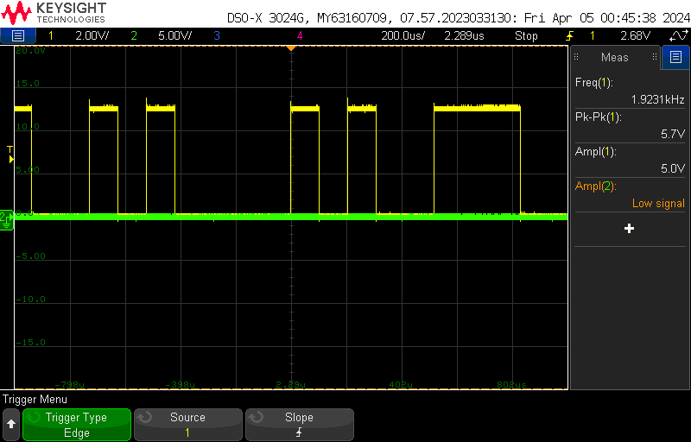**A screenshot of a computer

   Description automatically generatedUART output:**

Captured the state of the Tx channel when data was sent out of the Arduino board and confirmed that UART is working fine.

1. **A screen shot of a graph

   Description automatically generatedA screen shot of a graph

   Description automatically generatedSteady and In-rush current**

Measured a voltage drop of 162.50mV across 0.5Ω, indicating a steady-state current draw of about 325mA. Noted a voltage drop of 851mV upon plugging in the power supply, indicating an inrush current draw of around 1.7A.

With the help of the noise shield provided below, we evaluated the performance of the Golden Arduino compared to a Commercial Arduino.

1. A screen shot of a graph

   Description automatically generatedA screen shot of a graph

   Description automatically generated**Quiet Low output observed with a greater number of switching digital pins acting as aggressors:**

From the commercial board, observed ground bounce noise of about 385.93mV and 1.47V on the quiet low digital pin.

From the Golden Arduino board, observed ground bounce noise of about 289.45mV and 996.98mV on the quiet low digital pin.

1. A screen shot of a graph

   Description automatically generatedA screen shot of a graph

   Description automatically generated **Quiet Low output observed with just one digital pin acting as an aggressor:**

From the commercial board, observed ground bounce noise of about 217mV and 184mV on the quiet low digital pin.

From the Golden Arduino board, observed ground bounce noise of about 104.52mV and 88.44mV on the quiet low digital pin.

1. A screen shot of a graph

   Description automatically generatedA screen shot of a graph

   Description automatically generated **Quiet High output observed with the IC acting as an aggressor:**

From the commercial board, observed power rail noise of about 627mV and 731.66mV on the quiet high digital pin.

From the Golden Arduino board, observed power rail noise of about 385.93mV and 578.89mV on the quiet high digital pin.

1. A screen shot of a graph

   Description automatically generatedA screen shot of a graph

   Description automatically generated **Quiet High output observed with the entire board acting as an aggressor:**

From the commercial board, observed power rail noise of about 482.41mV and 321.6mV on the quiet high digital pin.

From the Golden Arduino board, observed power rail noise of about 410mV and 337.69mV on the quiet high digital pin.

1. A screen shot of a graph

   Description automatically generatedA screen shot of a graph

   Description automatically generated**Near field emissions:**

From the Commercial Arduino board, observed around 264.8mV and 555.8mV of NFE (near field emission).

From the Golden Arduino, observed around 27.6mV and 29.3mV of NFE (near field emission). Moreover the maximum noise is produced from switching digital pin.

1. **A screen shot of a graph

   Description automatically generatedA screen shot of a graph

   Description automatically generatedDigital pin output:**

In the commercial board, a rise time of 4ns and fall time of 5ns were observed when digital pin 13 was triggered to output a signal of 5Hz.

The rise time of 4.2ns and fall time of 4.8ns were noted when digital pin 13 is triggered to output a signal of 5Hz on the Golden Arduino board. This signifies that there is not much difference in signal timing characteristics between the Golden Arduino and the commercial board. Otherwise, it could lead to jitter in high-frequency communication signal transmission.

1. **A graph on a black background

   Description automatically generatedA screen shot of a graph

   Description automatically generatedReset pin:**  
   Observed a rise time of 1.78ms at the commercial board to reach logic high once the reset button is pressed. Similarly, a rise time of 201.93ms was observed at the Golden Arduino board, demonstrating better control over switch debouncing. Both boards maintain the reset pin low for more than 10 microseconds as required by the microcontroller.
2. **A screen shot of a graph

   Description automatically generatedA screen shot of a graph

   Description automatically generated Thevenin resistance and voltage at digital pin 12:**

The Thevenin voltage measured about 5.23V. After adding a 33ohm resistor as a load, the calculated load voltage is about 2.57V. Therefore, the Thevenin resistance (internal resistance of the voltage source, here microcontroller) is **34.15 ohms.**

1. **Noise summary of Commercial Board and Golden Arduino:**

|  |  |  |  |  |
| --- | --- | --- | --- | --- |
| Parameter | Trigger edge | Commercial board | Golden Arduino | Change in noise (%) |
| Current through 50ohm resistor | rise | 37mA | 35mA |  |
| fall | 34mA | 35mA |
| Quiet Low with multiple aggressors | rise | 386mV | 290mV | 25 |
| fall | 1.47V | 997mV | 32 |
| Quiet Low with single aggressors | rise | 217mV | 185mV | 14 |
| fall | 105mV | 88 mV | 15 |
| Quiet High with micro controller as aggressor | rise | 627mV | 386mV | 38 |
| fall | 732mV | 579mV | 20 |
| Quiet High with whole board as aggressor | rise | 482mV | 410mV | 15 |
| fall | 322mV | 338mV | 4 |
| Near Field emission | rise | 265mV | 28mV | 89.5 |
| fall | 556mV | 29mV | 95 |

1. **What All worked**

|  |  |  |
| --- | --- | --- |
| characteristics | Result | Remarks |
| Obtaining a 5V power supply from the power jack and USB mini. | Worked |  |
| Measuring the 3.3V output from the LDO regulator. | Worked |  |
| Utilizing a 12MHz frequency oscillator for the USB data transmission. | Worked |  |
| Utilizing a 16MHz frequency oscillator for the system clock. | Worked |  |
| Data transmission via D+ and D- pins. | Worked |  |
| Data transmission via Tx and Rx. | Worked |  |
| Implementing proper microcontroller reset without debouncing. | Worked |  |
| Ensuring that LED indicators are working fine. | Worked |  |
| Reduced ground bounce compared to commercial board. | Worked |  |
| Achieving reduced ground bounce compared to a commercial board. | Worked |  |
| Achieving reduced power rail noise compared to a commercial board. | Worked |  |

1. **Mistakes**

* Missed labelling the reset switch.
* Placed components too close to each other, which made soldering the components difficult.
* Forgot to add independent ICSP pins.

1. **Key learnings**

* Prototype Design: Practicing the entire design flow to gain hands-on experience.
* Datasheet Reading: Extracting useful information while navigating ambiguity.
* Feature Incorporation: Adding extra features to enhance functionality and evaluation options.
* Prototype Elements: Including test points, LEDs, and isolation switches for testing and debugging.
* Initial Design Phase: Beginning with POR, sourcing non-commodity parts, and prototyping on breadboards.
* Signal Routing: Employing best practices to minimize cross talk and power rail noise by avoiding cross under.
* Board Improvements: Identifying areas for enhancement in commercial boards to optimize performance.
* Inrush Current Measurement: Understanding and measuring inrush current to prevent damage to components and ensure proper functioning of the circuit.
* Importance of Differential Pairs: Recognizing the significance of using differential pairs to minimize noise and improve signal integrity in high-speed communication lines.
* Microcontroller Boot loading: Learning the process of boot loading a microcontroller to load firmware onto it, enabling it to execute specific tasks upon startup.